

|  |  |  |  |
| --- | --- | --- | --- |
| Academic Year | 2022 – 2023 | | |
| Semester | Fall | Winter | Summer |
| Course Code - Name | BAN110 | | |
| Instructor | Dr. Razi Iqbal | | |
| Assessment | Assignment 4 |  | |

**Student ID 176938215**

**Student Name Rongzhao Yi**

**Assignment 4**

The main purpose of this lab is to get students familiarize with PROC SQL and Joins.

**Instructions:**

* You are required to submit your answers in this document by pasting your SAS code under the solutions heading below.
* Please do not submit .sas files. Submit only this word document with your code inside it.
* Total Marks for this assignment are 5 marks.
* Students having exactly similar code will get a straight 0.
* You are required to complete these exercises using SAS.
* The deadline for submission of this assignment is April 4, end of the day.

**Question**

You are provided with the dataset ‘Superstore.xlsx’ file. It is an excel file with three sheets, ‘Orders’, ‘Returns’ and ‘People’. You are required to perform the following tasks using this dataset in SAS:

* Import the data from the excel sheet in SAS.
* Make sure you create at least 2 datasets in SAS namely Orders which would get all the data from Orders sheet and Returns which would get all the data from the Returns sheet in the excel.
* Use Proc SQL to perform the following tasks:
  + Get only the records for the orders that have been returned by joining Orders and Returns datasets.
  + Print only the returned orders from **California** under **Technology** category with **Quantity** greater than **5**.
  + Make sure your results are sorted by Order_Date in ascending order (you might have to do some research on how to do this in PROC SQL).
* Do not use any other procedure except PROC IMPORT and PROC SQL. You cannot use a DATA module for this assignment.
* Below is the expected output of this program:

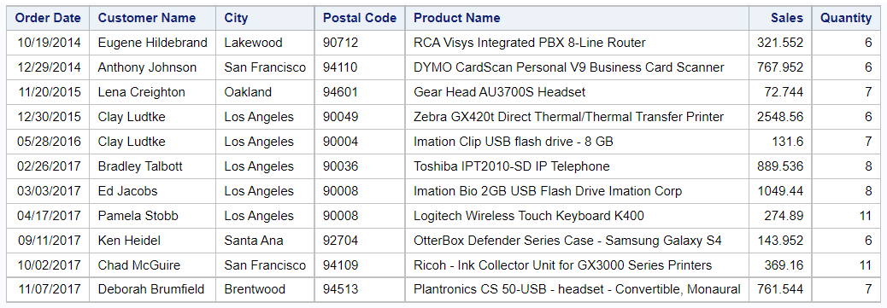

**Make sure to include only the columns shown in the screenshot above.**

**Solution**

